Afternoon Tea Menu

Finger Sandwiches & Fresh Rolls
Local Smoked Salmon on Horseradish and Whole Wheat Bread
(gluten, milk, fish)
Free Range Egg and Watercress on White Bread (v)
(egg, gluten, milk)
Chicken and Spring Onion Mayonnaise on Tarragon Bread
(gluten, milk)
Suffolk Ham & English Mustard Mayonnaise on Tomato Bread
(gluten, mustard, milk)

Savouries
Newmarket Sausage Roll
(gluten, egg)
Tomato Pesto Palmier (v)
(gluten, egg, milk, nuts)
Warm Scones
A choice of Plain or Fruit (v)
(gluten, egg, milk, sulphites)
With Tiptree Strawberry Jam, Clotted Cream & Homemade Lemon Curd

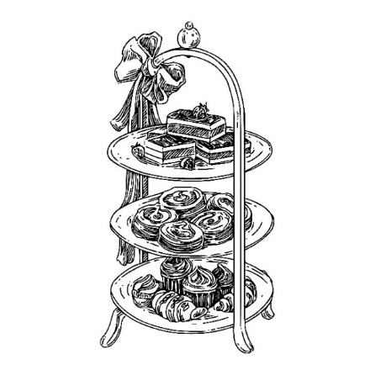
Cake Selection
Rhubarb and Custard Macaron (v)
(nuts, egg, milk)
Spiced Apple Trifle (v)
(gluten, milk, egg)
Pineapple and Ginger Cake (v)
(gluten, egg, milk)
Banoffi Pie (v)
(gluten, milk, egg, soya)
Passion Fruit and White Chocolate Mousse (v)
(milk, egg, soya)
Full Afternoon Tea with a Selection of Teas or Cafetiere of Coffee £28.00
Champagne Afternoon Tea including a Glass of Billecart-Salmon Brut Reserve £41.50

Afternoon Tea Drinks Selection

Your choice of tea

Everyday Brew - Robust in flavour, a blend of three teas Gutsy Assam, Mellow Ceylon & powerful Rwandan.

Darjeeling Earl Grey Tea - A strong Earl Grey, full of Bergamot, fragrant full flavour, exotic flora tones with zesty citrus Bergamot

Honeybush & Rooibos – Two unique South African plants, growing only in the Cederberg Mountain region naturally decaffeinated, soothing and full of nutrients. An Earthy, mahogany coloured nectar that gives way to a subtly, nutty flavour.

Mao Feng Green Tea – Light and Clean, this tea has a delicate natural taste of fresh air, Peaches and Apricots. a Great example of a Classic Green Tea.

Peppermint Leaf Tea – Whole Mint leaves for big flavour, then refreshing and vibrant Mint Tea.

Chamomile Flowers Tea – Tea full of whole Chamomile flowers, A beautiful yellow cup of tea which gives way to a sweet and surprisingly juicy flavour of Camomile, very soothing.

Super Fruit Tea –Tea infused with invigorating Hibiscus flowers and Redberries, punchy and full of fruit flavours, a beautiful red hue.

Lemon & Ginger Tea – Subtle Lemon tones with a Ginger kick, an uplifting tea
Your choice of coffee
Cafetiere
Decaffeinated Cafetiere

Your choice of premium coffee
£3.95
Espresso/ Double Espresso
Decaffeinated Espresso
Machiatto
Americano
Latte
Flat White
Cappuccino
Mocha
Sparkling & Champagne
125ml/Bottle
Prosecco Spumante “Borgo Alato”
£7.50/£39.00
Champagne

Billecart-Salmon Brut Reserve £13.50/£80.00
Billecart-Salmon Brut Rose £17.50/£99.00
Billecart-Salmon Blanc de Blancs
£21.50/£120.00
English Sparkling wine

Gusborne, Twenty Eighteen Blanc de Blancs
£59.00
Gusborne, Twenty Eighteen Rose
£63.00

